Decorator:
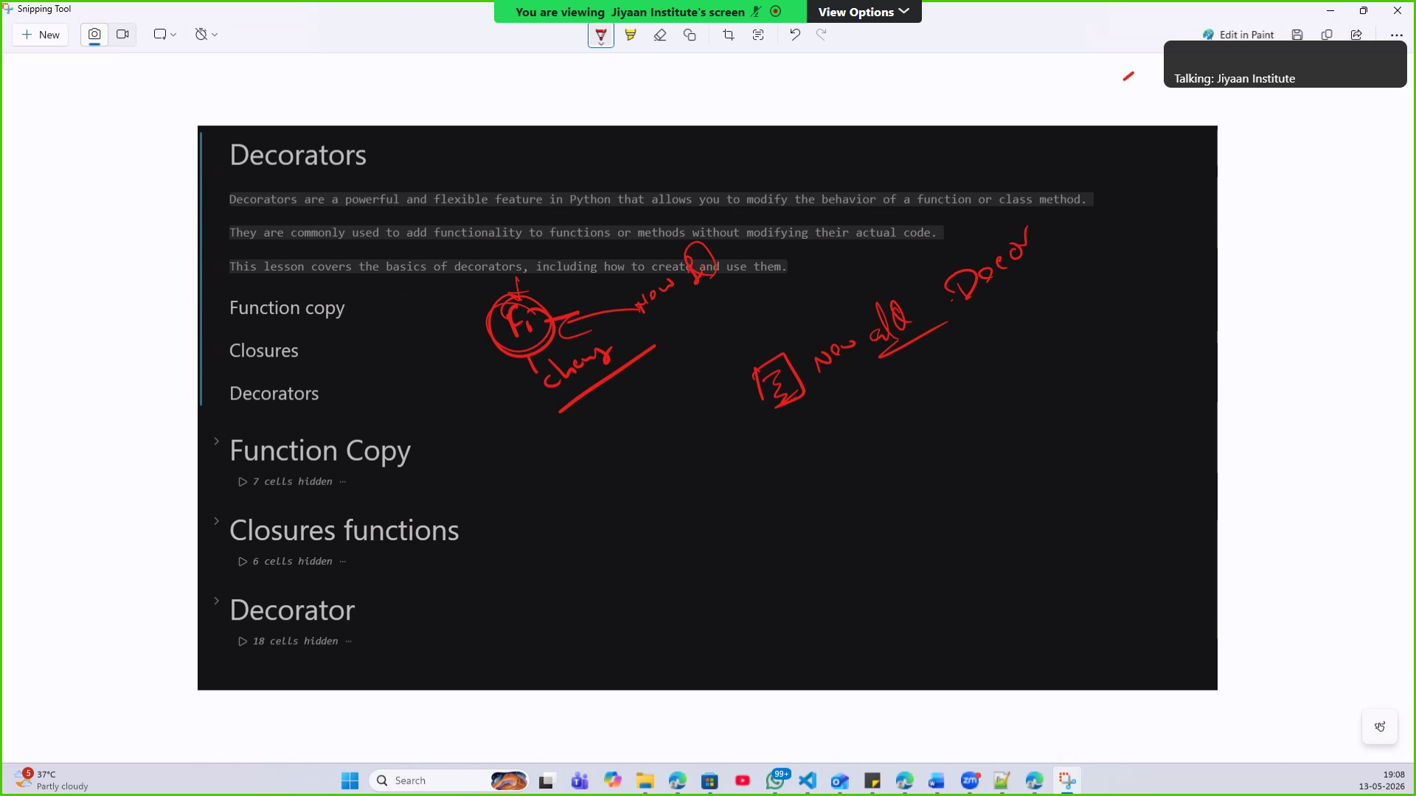

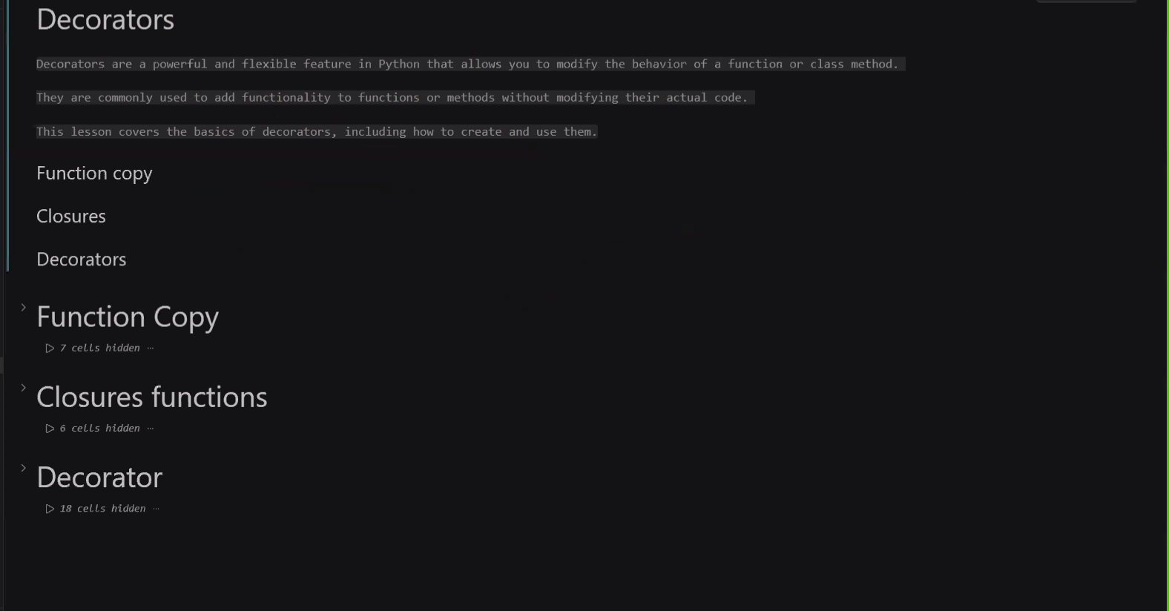
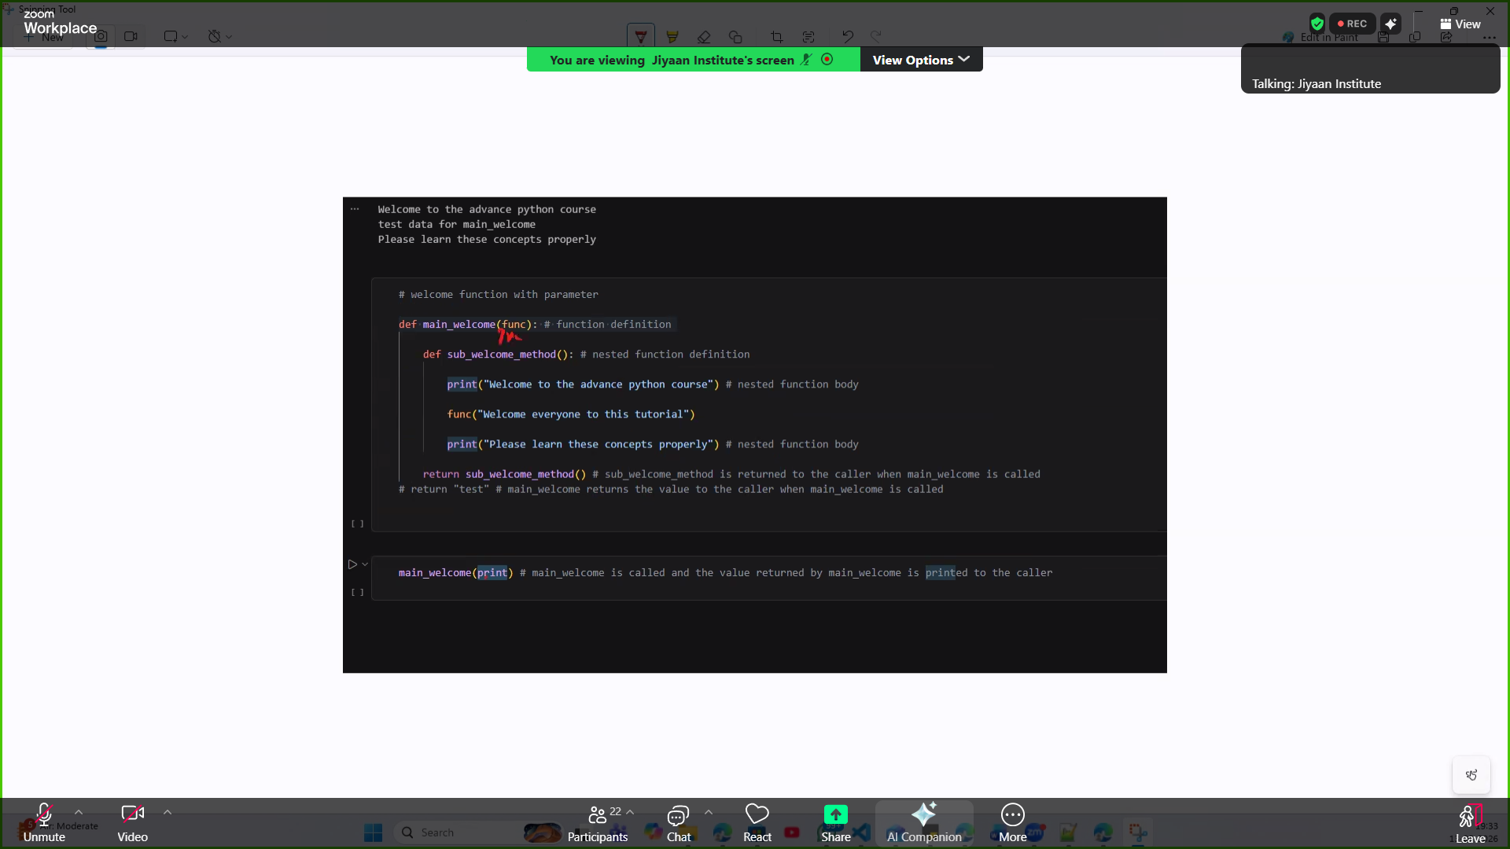
- Passing function as input to a function
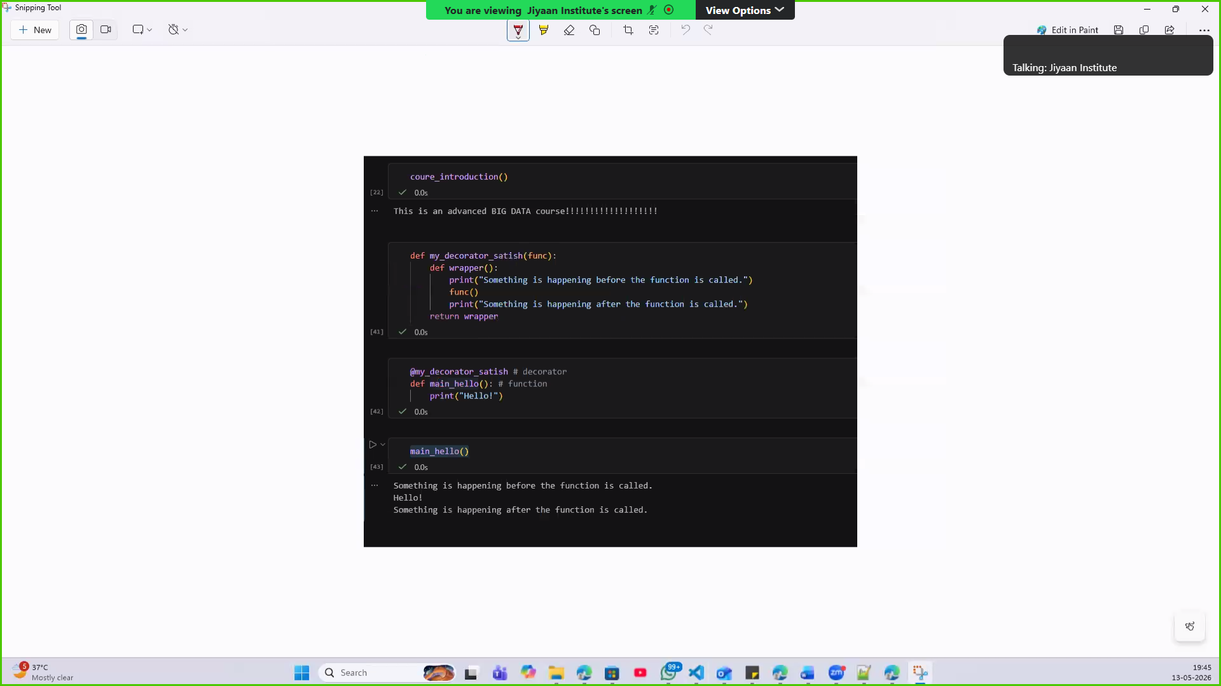
- Closures, wrappers and decorators
- Wrapping should be done to make it work as decorators
- If wrapping is not done then it is called closures
- Main func() cannot becalled when closures are used (wrapping not done)
- Should call main func() when decorator is applied, otherwise when mail func() is called error is thrown
- Decorator, which once created can be used with any no of functions when required and can also create multiple decorator functions


